Edward Duh ( 杜維洲 )

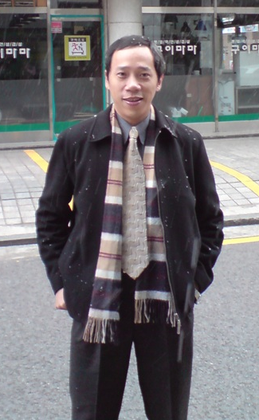
Name: Wei-Jou (Edward) Duh
Phone (office): 02-33669559
Phone (Mobile): +886-918168461
E-mail: edward.duh@gmail.com
edwardduh@ntu.edu.tw

Education
1989/9 ~1992/6 Ph.D., Computer Science, National Taiwan University, Taipei, Taiwan
( 台灣大學資訊工程研究所博士 )
1987/9~1989/6 Master, Computer Science, National Taiwan University, Taipei, Taiwan
( 台灣大學資訊工程研究所碩士 )
1983/9~1987/6 Bachelor, Computer Engineering, National Chiao Tung University, HsinChu, Taiwan
( 交通大學計算機工程學士 )

Introduction
My background is in Computer Engineering, and my research areas include digital signal processing, multimedia processing, embedded systems, servo control, and, more recently, artificial intelligence. From 1994 to 2014, I worked for several fabless IC design companies. During my time there, I led the engineering team to validate chips, developed firmware and software for turn-key solutions, and supported customer customizations. I am familiar with every aspect of embedded systems, from the chip, firmware, system hardware, and software. I experienced several startup cycles, both US-based and Taiwan-based. From 2014 to 2018, I was involved with system-level startups. I co-founded Orzard Technologies and developed IoT solutions, including a bus driver monitoring system and a keyless Bluetooth door lock.
Starting from 2018, I focused on the AI area. I worked as an AI lecturer, with more than 250 teaching hours. I joined the AI Research Center at NTU (AINTU) as the CEO in 2019, hoping to bridge academia and industry. As the CEO of AINTU, leveraging my past industry experience, I can smoothly communicate with all stakeholders, including the government (mainly NSTC), universities, research faculties, and industry partners. I have successfully supported more than 32 research teams in conducting AI research; I have successfully engaged with Google and held a series of joint AI Bootcamps for seven consecutive years; I have successfully enabled Google’s research sponsorships for NTU’s faculties, averaging 6-8 projects per year; I have successfully organized several large-scale academic events in Taiwan, such as MLSS 2021 and the top-tier international conference ACM SIGIR 2023. I have successfully secured research funding from NSTC with 4 proposals, amounting to approximately NTD$48 million per year on average. I led a large-scale research project called “Smart Emergency Department,” where we successfully developed 13 AI models and conducted three-month clinical trials at NTU Hospital in 2022.
In summary, I have a strong and wide range of technical backgrounds in embedded systems; I have team management and project management experience; I have a strong collaborative relationship with academic researchers in the AI area; I also have hands-on experience in leveraging AI technology for transforming healthcare applications. I am interested in exploring challenging opportunities.

